Semantic Web

Lab Sheet 2

S Abhishek

AM.EN.U4CSE19147

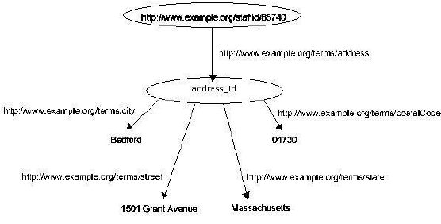

<?xml:namespace ns = "http://www.w3.org/RDF/RDF/"?>

<?xml:namespace staff = "http://www.example.org/terms/"?>

<RDF:RDF>

    <RDF:Description rdf:resource = "http://www.example.org/staffid/85740">

        <RDF:staff rdf:resource = "http://www.example.org/terms/address" rdf:HREF = "#Address_ID"/>

    </RDF:Description>

    <RDF:Description ID = "#Address_ID">

        <staff:City>Bedford</staff:City>

        <staff:Street>1501 Grant Avenue</staff:Street>

        <staff:state>Massachusetts</staff:state>

        <staff:postalCode>01730</staff:postalCode>

    </RDF:Description>

</RDF:RDF>

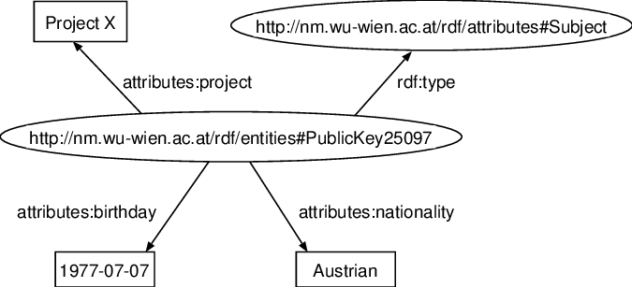

<?xml version="1.0"?>

<rdf:RDF

    xmlns:rdf = "http://www.w3.org/1999/02/22-rdf-syntax-ns#"

    xmlns:rdfs = "http://www.w3.org/2000/01/rdf-schema#"

    xml:sub = "http://nm.wu-wien.ac.at/rdf/entities#PublicKay25097">

    <rdf:Description rdf:ID = "Subject">

        <rdf:type rdf:resource="http://nm.wu-wien.ac.at/rdf/attributes#Subject"/>

    </rdf:Description>

    <rdf:Description rdf:about="http://nm.wu-wien.ac.at/rdf/entities#PublicKay25097">

        <sub:project> Project X </sub:project>

        <sub:birthday> 1977 - 07 - 07 </sub:birthday>

        <sub:nationality> Austrian </sub:nationality>

    </rdf:Description>

</rdf:RDF>

Thankyou!!